**Language and Version Manager**

# Purpose of Language and Version manager –

This module will help to Add Version and Copy Content on “n” number of items with few clicks.

To achieve both functionalities (Add Version and Copy Content) we have created a **Speak UI** module which is easy to handle and it will help to save development/content editor time.

This module provides two basic functionalities as follows -

1. **Add Version** – Add specific language version on “n” number of items by single click.
2. **Copy Content** – Copy content from one language version to another language version on multiple items.

# Installation of Language and Version Manager –

1. Install ***Language And Version Manager-1.0.zip*** sitecore package from Sitecore installation wizard.

# Post installation steps –

1. Rebuild master database search index.
2. If you are using any language fallback then you need to remove fallback from the language.

# How to launch Language and Version Manager after installation -

After installation of the module you can see language and version manager button on Sitecore Launchpad. Please see in below screenshot.

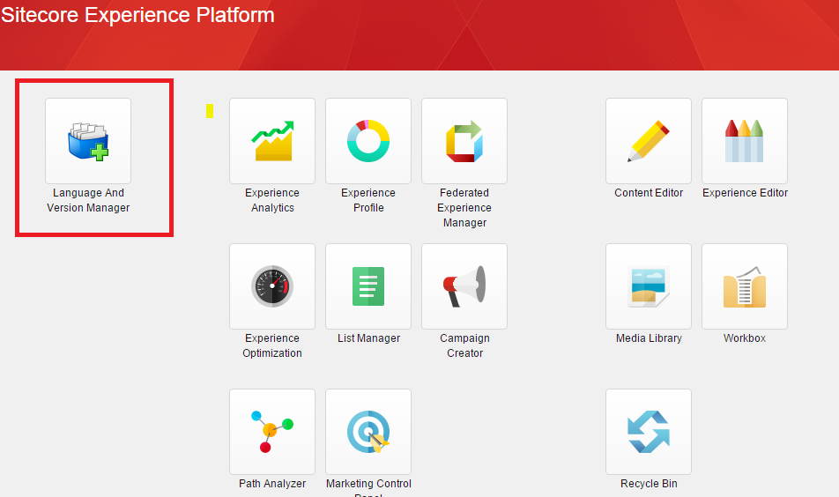

To use the functionalities of this module click on button provided in above screenshot.

# How to perform Add Version -

To add version on content items we have provided 2 simple ways –

1. Add Version on all content items of selected data template –
   1. Select data template from template tree.
   2. Select language from Language (Copy To) combo box.
   3. Click on Add Version button to execute this.

Please see below screenshot -

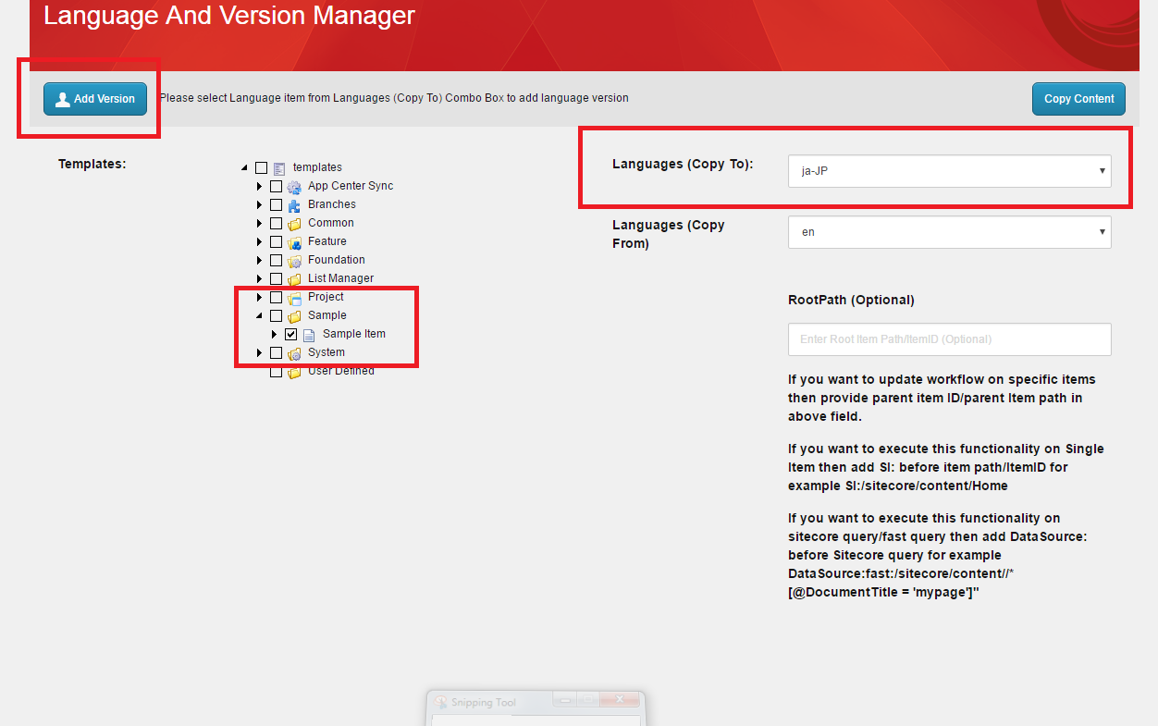

1. If you want to execute this add version functionality on specific content items then you can use **RootPath** field on bottom of the combo boxes.

To make it more easy and handy we have provide few filters in root path which will make you more specific about content items -

1. If you want to execute this functionality on only items under specific node then you need to select Data Template from Template tree and need to provide ***ParentItem Path/Parent Item ID*** in this **RootPath** text box. It will execute this functionality on all the items under provided node and also on same node item.
2. If you want to execute this functionality on only Single item then you don’t need to select any template from template tree, you just need to provide ***Item Path/ Item ID*** in **RootPath** text box with “SI:” keyword.

**For example - SI:/sitecore/content/home**

1. If you want to execute this functionality on *Sitecore query/ fast queries* then also you don’t need to select any template from template tree, you just need to provide ***Sitecore query / Fast query*** in **RootPath** text box with DataSource: keyword.

**For example - DataSource:fast:/sitecore/content//*[@DocumentTitle = 'mypage']"**

**Note –** This module will not add version of an item if item is already havingversion in selected language.

# How to perform Copy Content functionality -

With this functionality we are providing options to copy content from one language to another language. We have provided 2 ways to filter the content items to perform this functionality –

**Note –** If any of the field in target language (In which language you want to copy content) version is already having value/content then it will not replace the content of that field. It will leave that field as it is.

1. Copy content on all content items of selected data template –
   1. Select data template from template tree.
   2. Select target language (in which you want to copy content) from Language (Copy To) combo box.
   3. Select source language (from which you want to copy content) from Language (Copy From) combo box.
   4. Click on Copy Content button.

If the item doesn’t have language version created then it will first create language version of that item and then it will copy content.

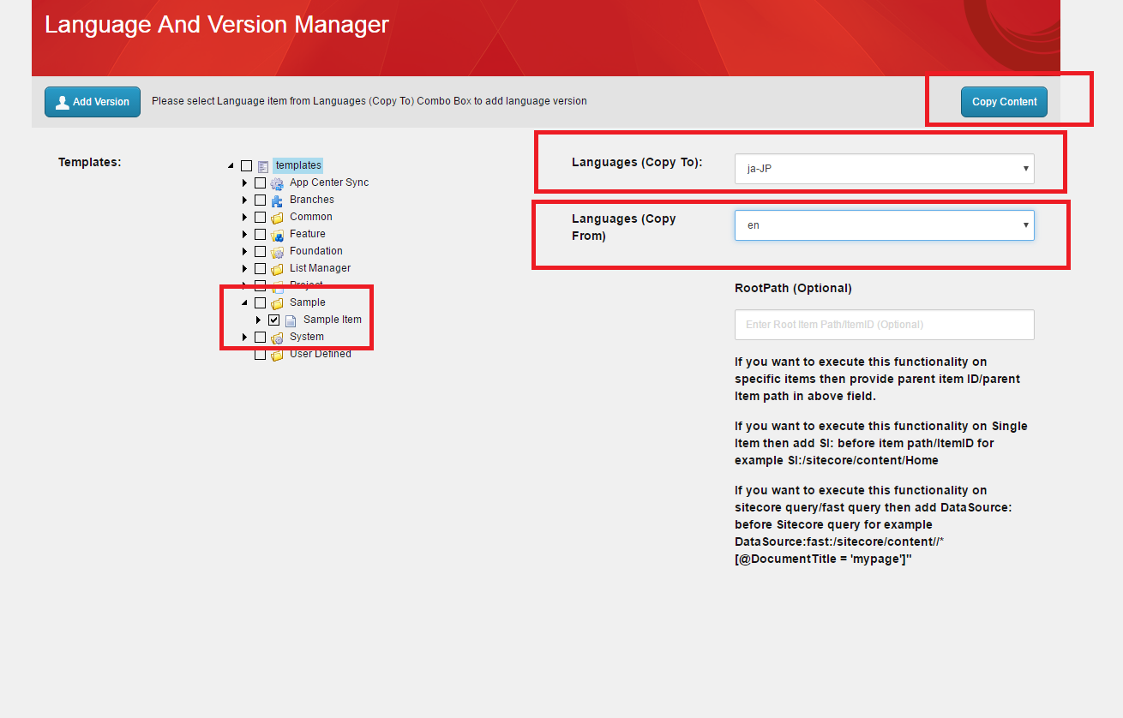

1. If you want to execute this Copy content functionality on specific content items then we are using **RootPath** field on bottom of the combo boxes.

To make it more easy and handy we have provide few filters in root path which will make you more specific about content items -

* 1. If you want to execute this functionality on only items under specific node then you need to select Data Template from Template tree and need to provide **ParentItem Path/Parent Item ID** in this **RootPath** text box. It will execute this functionality on all the items under provided node and also on same node item.
  2. If you want to execute this functionality on only Single item then you don’t need to select any template from template tree, you just need to provide ***Item Path/ Item ID*** in **RootPath** text box with SI: keyword.

**For example -** **SI:/sitecore/content/home**

* 1. If you want to execute this functionality on ***Sitecore query/ fast query*** then also you don’t need to select any template from template tree, you just need to provide ***Sitecore query / Fast query*** in **RootPath** text box with DataSource: keyword

**For example - DataSource:fast:/sitecore/content//*[@DocumentTitle = 'mypage']"**

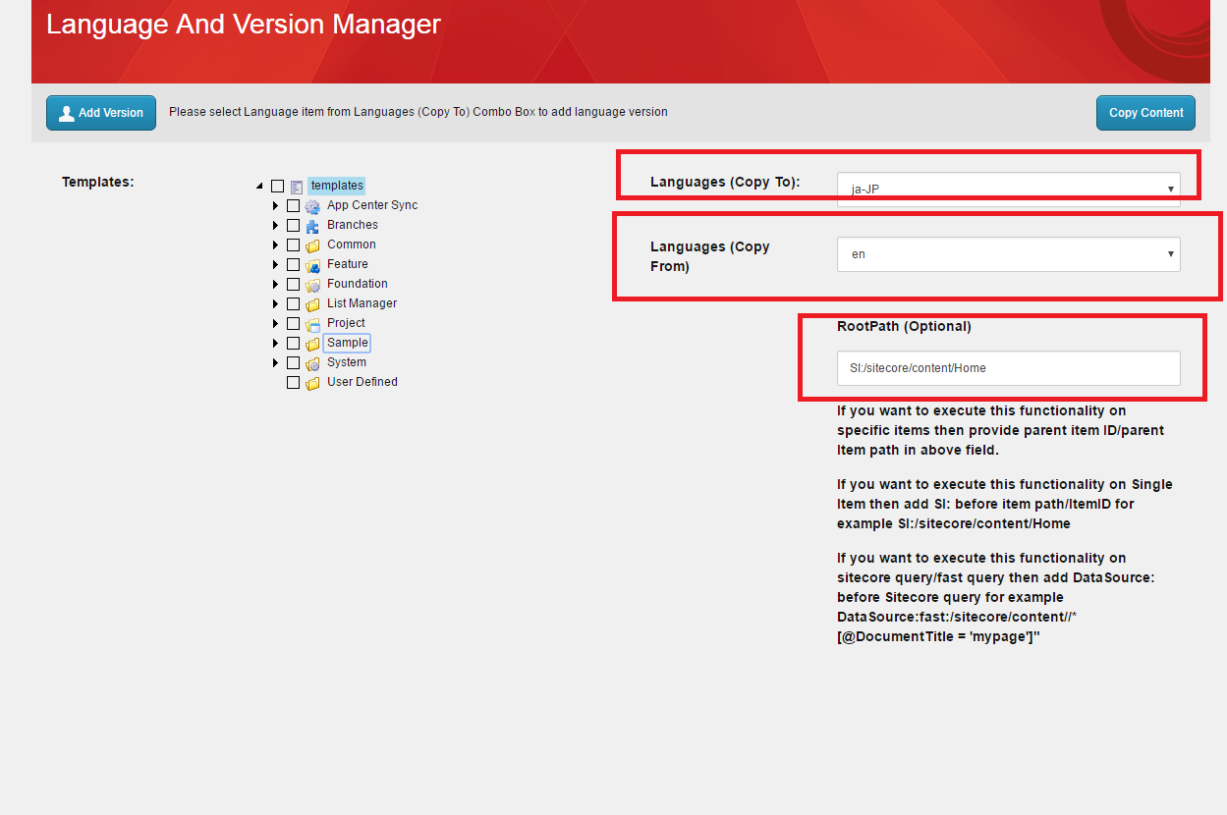

# How to uninstall this module from your Sitecore instance –

If you have used this module and don’t want this in your Sitecore instance anymore then you can easily uninstall by deleting some items and files as given below.

1. Remove Items from Sitecore -
   1. Delete ***/sitecore/client/Your Apps/Language And Version Manager*** item with its children.
   2. Delete ***/sitecore/client/Applications/Launchpad/PageSettings/Buttons/Language And Version Manager*** item with children.
2. Remove Files from website
   1. Remove ***LanguageAndVersionManager.dll*** from bin folder under website.
   2. Remove ***Language And Version Manager*** folderfrom ***Website\sitecore\shell\client*** location.